Date: ___________
Practical No. 09
Aim: Optimization Modeling and Simulation Modeling:
a. Formulate an optimization model (e.g., linear programming, integer Programming) to solve a real-world business problem and analyze the optimal solution.
b. Use simulation modeling to evaluate different business scenarios, such as capacity planning, inventory management, or pricing strategies, and assess their impact on performance metrics.
To formulate an optimization model for a real-world business problem and find the optimal solution using Python.
Problem Statement
A company produces Product A and Product B.
Resource / Product Labor hours  Material units  Profit per unit | Product A | Product B | Available 40  50  —
 | 2 | 1 | Available 40  50  —
 | 1 | 2 | Available 40  50  —
 | ₹40 | ₹30 | Available 40  50  —

Find the number of Product A and Product B units to produce to maximize total profit.
Optimization Model
Let:
• x = units of Product A
• y = units of Product B
Objective
Maximize Z = 40x + 30y
Constraints
2x + y ≤ 40
X + 2y ≤ 50
Non-negativity:
x, y≥0
INPUT:
from scipy.optimize import linprog
# Profit coefficients
# linprog minimizes, so use negative profit
profit = [-40, -30]
# Resource constraints
A = [
[2, 1], # Labor
[1, 2] # Material
]
# Available resources
b = [40, 50]
# Solve the optimization problem
result = linprog(
profit,
A_ub=A,
b_ub=b,
bounds=[(0, None), (0, None)],
method="highs"
)
# Display output
if result.success:
product_A = result.x[0]
product_B = result.x[1]
maximum_profit = -result.fun
print("Optimal Production Plan")
print("-----------------------")
print("Product A:", round(product_A, 2), "units") print("Product B:", round(product_B, 2), "units") print("Maximum Profit: ₹", round(maximum_profit, 2)) else:
print("No optimal solution found.")
OUTPUT:
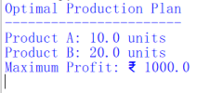
Conclusion
The company should produce 10 units of Product A and 20 units of Product B. This gives the maximum profit of ₹1,000, while using all available labor and material resources.
b.
# Simulation Modeling for Pricing Strategies
import random
random.seed(10)
# Possible customer demand
customer_demand = [random.randint(50, 100) for i in range(5)]
# Different pricing strategies
prices = [100, 120, 150]
# Cost per product
cost = 60
print("Customer Demand:", customer_demand)
for price in prices:
total_revenue = 0
total_profit = 0
total_sales = 0
for demand in customer_demand:
# Demand decreases as price increases
if price == 100:
sales = demand
elif price == 120:
sales = int(demand * 0.8)
else:
sales = int(demand * 0.6)
revenue = sales * price
profit = sales * (price - cost)
total_sales += sales
total_revenue += revenue
total_profit += profit
print("\nProduct Price: Rs.", price)
print("Total Sales:", total_sales)
print("Total Revenue: Rs.", total_revenue)
print("Total Profit: Rs.", total_profit)
OUTPUT:
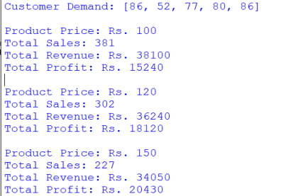
Result Analysis
Product Price ₹100  ₹120  ₹150 | Total Sales | Total Revenue | Total Profit ₹15,240  ₹18,240  ₹20,520
Product Price ₹100  ₹120  ₹150 | 381 | ₹38,100 | Total Profit ₹15,240  ₹18,240  ₹20,520
Product Price ₹100  ₹120  ₹150 | 304 | ₹36,480 | Total Profit ₹15,240  ₹18,240  ₹20,520
Product Price ₹100  ₹120  ₹150 | 228 | ₹34,200 | Total Profit ₹15,240  ₹18,240  ₹20,520

Conclusion: The simulation shows that increasing the product price reduces sales volume but increases total profit in this example. The ₹150 pricing strategy provides the highest profit of ₹20,520. Therefore, simulation modeling helps businesses compare pricing strategies and make informed decisions based on revenue and profit.

